Exercises:

Introduction to Statistics

with GraphPad Prism

Bootcamp

Version 2019-06

Licence
This manual is © 2015-2019, Anne Segonds-Pichon.

This manual is distributed under the creative commons Attribution-Non-Commercial-Share Alike 2.0 licence. This means that you are free:

- to copy, distribute, display, and perform the work

- to make derivative works

Under the following conditions:

- Attribution. You must give the original author credit.

- Non-Commercial. You may not use this work for commercial purposes.

- Share Alike. If you alter, transform, or build upon this work, you may distribute the resulting work only under a licence identical to this one.

Please note that:

- For any reuse or distribution, you must make clear to others the licence terms of this work.
- Any of these conditions can be waived if you get permission from the copyright holder.
- Nothing in this license impairs or restricts the author's moral rights.

Full details of this licence can be found at
http://creativecommons.org/licenses/by-nc-sa/2.0/uk/legalcode

Exercise 1:

(Data from: http://www.sciencealert.com/scientists-are-painting-eyes-on-cows-butts-to-stop-lions-getting-shot)
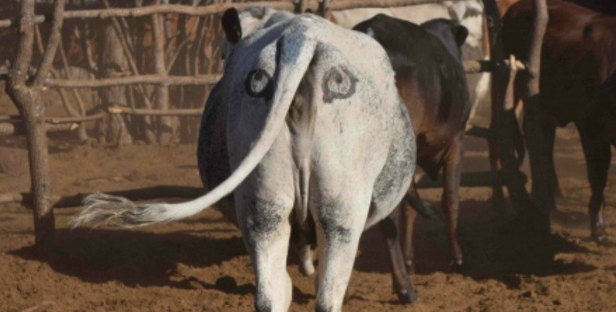

Scientists have come up with a solution that will reduce the number of lions being shot by farmers in Africa - painting eyes on the butts of cows. It sounds a little crazy, but early trials suggest that lions are less likely to attack livestock when they think they’re being watched - and less livestock attacks could help farmers and lions co-exist more peacefully.

Pilot study over 6 weeks: 3 out of 39 unpainted cows were killed by lions, none of the 23 painted cows from the same herd were killed.
- Do you think the observed effect is meaningful to the extent that such a ‘treatment’ should be applied? Consider ethics, economics, conservation …
- Run a power calculation to find out how many cows should be included in the study.

Exercise 2:

(Data from ‘Discovering Stats with SPSS’ by Andy Field)

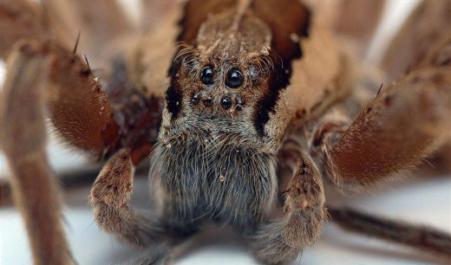

Pilot study: 10 arachnophobes were asked to perform 2 tasks:
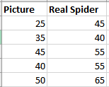
Task 1: Group1 (n=5): to play with a big hairy tarantula spider with big fangs and an evil look in its eight eyes.
Task 2: Group 2 (n=5): to look only pictures of the same hairy tarantula.
Anxiety scores were measured for each group (0 to 100).

- Use the data to calculate the values for a power calculation
- Run a power calculation to find out how many subjects should be included in the study.

Exercise 3:

Question: Do male and female coyotes differ in size?
No data from a pilot study but some information in the literature.
In a study run in similar conditions as in the intended, male coyotes were found to measure: 92cm+/- 7cm (SD)
We expect a 5% difference between genders.
- Run a power calculation to find out how many coyotes should be included in the study.

Exercise 4: coyote.xlsx

The file contains body individual body length of male and female coyotes.
Question: Question: do male and female coyotes differ in size?
- Plot the data as stripchart, boxplot and violinplot

Exercise 5: working.memory.xlsx

A researcher is studying the effects of dopamine (DA) depletion on working memory in rhesus monkeys. A group of rhesus monkeys (n=15) performs a task involving memory after having received a placebo. Their performance is graded on a scale from 0 to 100. They are then asked to perform the same task after having received a dopamine depleting agent.

Question: does dopamine affect working memory in rhesus monkeys?
- Explore graphically the data
- Answer the question statistically using the appropriate test

Exercise 6: smelly teeshirt.xlsx

Hypothesis: Group body odour is less disgusting when associated with an in-group member versus an out-group member. Two groups of Cambridge University students are presented with one of two smelly, worn t-shirts with university logos.

Question: are Cambridge students more disgusted by worn smelly T-shirts from Oxford or Cambridge? Disgust score: 1 to 7, with 7 the most disgusting.

- Explore the data with an appropriate combination of 2 graphs
- Answer the question with a non-parametric approach
- What do you think about the design?

Exercise 7: botulinum.xlsx

A group of 9 disabled children with muscle spasticity (or extreme muscle tightness limiting movement) in their right upper limb underwent a course of injections with botulinum toxin to reduce spasticity levels.

Question: do botulinum toxin injections reduce muscle spasticity levels?
Score: 1 to 10, with 10 the highest spasticity
- Answer the question with a non-parametric approach

Exercise 8: protein.expression.xlsx

Question: Difference in protein expression between 5 cell types?
- Plot the data
- Check the assumptions for parametric test

Exercise 9: neutrophils.xlsx

A researcher is looking at the difference between 4 cell groups. He has run the experiment 5 times. Within each experiment, he has neutrophils from a WT (control), a KO, a KO+Treatment 1 and a KO+Treatment2.
Question: Is there a difference between KO with/without treatment and WT?
- Explore the data. Try to do it in a way that account for the experimental design.
- Analyse the data by choosing the appropriate statistical approach.

Exercise 10: creatine.xlsx

Creatine, a supplement popular among body builders. To test its effect an experiment is run with 3 groups: No creatine; Once a day; and Twice a day.

Question: does the average weight gain depend on the creatine group to which people were assigned?
- Plot the data
- Answer the question with a non-parametric approach

Exercise 11: Power calculation

Power calculation
Preliminary results from a pilot study: 25% line-danced after having received affection as a reward vs. 70% after having received food.
- How many cats do we need?
Exercise 12: Cane toads

A researcher decided to check the hypothesis that the proportion of cane toads with intestinal parasites was the same in 3 different areas of Queensland.
From Statistics Explained by Steve McKillup

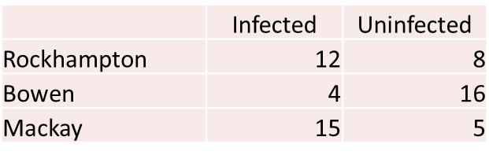

- Question 1: Is the proportion of cane toads infected by intestinal parasites the same in 3 different areas of Queensland?
- Question 2: Is the proportion of infected cane toads lower in Bowen than in the other 2 areas?

