Exercises:

Plotting Complex Figures Using R

Version 2017-11

Licence
This manual is © 2016-17, Simon Andrews.

This manual is distributed under the creative commons Attribution-Non-Commercial-Share Alike 2.0 licence. This means that you are free:

- to copy, distribute, display, and perform the work

- to make derivative works

Under the following conditions:

- Attribution. You must give the original author credit.

- Non-Commercial. You may not use this work for commercial purposes.

- Share Alike. If you alter, transform, or build upon this work, you may distribute the resulting work only under a licence identical to this one.

Please note that:

- For any reuse or distribution, you must make clear to others the licence terms of this work.
- Any of these conditions can be waived if you get permission from the copyright holder.
- Nothing in this license impairs or restricts the author's moral rights.

Full details of this licence can be found at
http://creativecommons.org/licenses/by-nc-sa/2.0/uk/legalcode

Exercise 1: Customising simple plots
- The file weight_chart.txt contains data for a growth chart for a typical baby over the first 9 months of its life. Read this file into a data frame using the read.delim function. Use the plot function to draw this as a point and line graph (type=”b”) with the following changes. Apply each one sequentially so you can see the effect it has on the plot.
  - Change the point character to be a filled square (pch=15)
  - Change the plot point size to be 1.5x normal size (cex=1.5)
  - Change the line thickness to be twice the default size (lwd=2)
  - Change the y-axis to scale between 2 and 10kg (ylim=c(2,10))
  - Change the x-axis title to be Age (months) (xlab=”Age (months)”)
  - Change the y-axis title to be Weight (kg) (ylab=”Weight (kg)”)
  - Add a suitable title to the top of the plot (main=”Some title”)

- The file feature_counts.txt contains a summary of the number of features of different types in the mouse GRCm38 genome. Load this into a data frame using read.delim and then plot it as a barplot. Note that the data you need to barplot is contained within the Count column of the data frame, so you pass only that single column as the data for the plot.
Once you have the basic plot make the following changes:
  - The bars should be horizontal rather than vertical (horiz=TRUE).
  - The count axis should be labelled (xlab=”A title”)
  - The feature names should be added to the y axis. (set names.arg to the Feature column of the data frame)
  - The plot should be given a suitable title (main=”Some title”)
  - The text labels should all be horizontal (las=1) Note that you can pass this parameter either via par, or as an additional option to barplot.
  - The margins should be adjusted to accommodate the labels (par mar parameter). You need to supply a 4 element vector for the bottom,left,top and right margin values. Look at the value of par()$mar to see what the default values are so you know where to start. Note that you will have to redraw the barplot after making the changes with par.

- [Extension if you have time] Use this hist function to plot out the distribution of 10000 points sampled from a standard normal distribution (rnorm) along with another 10000 points sampled from the same distribution but with an offset of 4.
  - Example: c(rnorm(10000),rnorm(10000)+4)
  - Find a suitable number of breaks to make the plot look nicer (breaks=10 for example)

Exercise 2: Using colour

- The file male_female_counts.txt contains a time series split into male and female count values.
  - Plot this as a barplot
  - Make all bars different colours using the rainbow function
    - rainbow takes a single argument, which is the number of colours to generate, eg rainbow(10) Try making the vector of colours separately before passing it as the col argument to barplot (col=rainbow(10)).
    - Rather than hard coding the number of colours, think how you could use nrow to automatically generate the correct number of colours for the size of dataset.
  - Replot, and make the bars for the males a different colour to those for the females. In this case the male and female samples alternate so you can just pass a 2 colour vector to the col parameter to achieve this effect. (col=c(“blue2”,”red2”)) for example.

- The file up_down_expression.txt contains an expression comparison dataset, but has an extra column which classifies the rows into one of 3 groups (up,down or unchanging). Plot this as a scatterplot (plot) with the up being red, the down being blue and the unchanging being grey.
  - Read in the file using read.delim
  - Start by just plotting the Condition1 column against the Condition2 column in a plot
  - Pass the State column as the col parameter (col=up.down$State for example). This will set the colour according to the state of each point, but the colours will be set automatically from the output of palette Run palette() to see what colours are there initially and check that you can see how these relate to the colours you get in your plot.
  - Run levels() on the ‘State’ column data and match this with what you saw in palette() to see how each colour was selected. Work out what colours you would need to put into palette to get the colour selection you actually want.
  - Use the palette function to set the corresponding colours you want to use (eg palette(c(“red”,”green”,”blue”)) – but using the correct colours in the correct order.
  - Redraw the plot and check that the colours are now what you wanted.

- The file colour_to_value_map.r contains a function to map a value from a range to a colour from a predefined palette. The file expression_methylation.txt contains data for gene body methylation, promoter methylation and gene expression.
  - Draw a scatterplot (plot) of the promoter.meth column against the gene.meth column.
  - Now you can work on colouring this plot by the expression column. For this you are going to need to run the map.colours function we provided. This requires two bits of data – one is simply the values in the expression column, but the other is a vector of colours which define your colour scale.
    - You will need to start by constructing a colour palette function from grey to red.
      - Run colorRampPalette(c(“grey”,”red”)) to show that you can generate a function which will make colours running from grey to red.
      - Call the function to generate a set of 100 colours and save these into a suitably named variable ie: colorRampPalette(c(“grey”,”red”))(100).
    - Now generate your actual colour vector you’re going to use. Call the map.colours function you’ve been given with the set of expression column values, and the vector of colours you just generated. Save the per point colours which are returned into a new variable.
  - Finally redraw the plot passing the per point colours to the col parameter.

Exercise 3: Using Overlays

- The file chromosome_position_data.txt contains positional count data for 3 different datasets (a WT and two mutants). Plot this as a line graph (using plot(type=”l”)) showing the 3 different datasets overlaid.
  - You’ll need to do an initial plot with type=”l” specified followed by two additional layers using the lines function. The x values will be the Position column in each case. The y values will be the WT column for the initial plot, and then the Mut1 and Mut2 columns for the overlays.
  - Remember to calculate the full range of values across all 3 datasets when doing the initial plot so that all of the data will fit into the plot area. You can pass the whole data portion of the data frame (excluding the positions) to range to do the calculation ie: range(chr_positions[,2:4])
  - For the colours generate a 3 colour palette from the “Set1” RColorBrewer set using the brewer.pal(3,”Set1”) function and save it. Pass a different colour from the palette to each of the plotting functions you call.
  - Use the legend function, to put a legend at the “topleft” of the plot with the data names and the corresponding colours (using the fill parameter).
  - Make the lines 2x as thick as standard (lwd=2)
  - Add suitable labels to each axis (using xlab and ylab).
  - The general structure for your code will therefore be:

plot(
[position data], [wt data],
ylim=[range data],
type=”l”,
col=[first colour],
lwd=2
)

lines([position data], [mut1 data], col=[second colour], lwd=2)
lines([position data], [mut2 data], col=[third colour] , lwd=2)

legend(“topleft”,c(“wt”,”mut1”,”mut2”),fill=[vector of 3 colours])

- The file brain_bodyweight.txt contains data for the log10 brain and bodyweight for a range of species, along with an SEM measure for each point. Plot these data on a scatterplot (using plot) with error bars showing the mean +/- SEM and the names of the datasets under each point.

  - You will initially need to do a plot passing the Bodyweight and Brainweight columns as the data. Make sure this works before trying to add error bars.
  - You will need to add 2 sets of error bars, one for the Bodyweight and one for the Brainweight. These will be two separate additional layers, each consisting of an arrows function.
  - The arguments for each arrows function are:
    - The x (brainweight) start position
    - The y (bodyweight) start position
    - The x (brainweight) end position
    - The y (bodyweight) end position
    - Additional common options will be
      - angle=90 – to produce a flat head to the bars
      - code=3 – to get a bar at both ends of the line
      - length=0.05 – so the bars aren’t too long.

  - The start and end positions for one error bar will be the original value plus and minus the corresponding SEM. For example for the brainweight confidence interval the code would be something like:

arrows (
data$Bodyweight,
data$Brainweight – data$Brainweight.SEM,
data$Bodyweight,
data$Brainweight + data$Brainweight.SEM,
angle=90,
code=3,
length=0.05
)

You will, of course, need to replace “data” with whatever you actually called the data frame containing the data for this exercise. You would also need to repeat this modifying the Bodyweight values to get the Bodyweight error bars.

  - To add the names of the species just below each data point you would use the text function. The x and y values will just be the same as for the original plot (Brainweight and Bodyweight). The labels will be the Species column. Other options you will need to set will be:
    - pos=1 – to put the text underneath each point
    - cex=0.7 – to make the text slightly smaller

Plot Results
Below are examples of what the plots you will draw in these exercises should end up looking like.

Exercise 1:
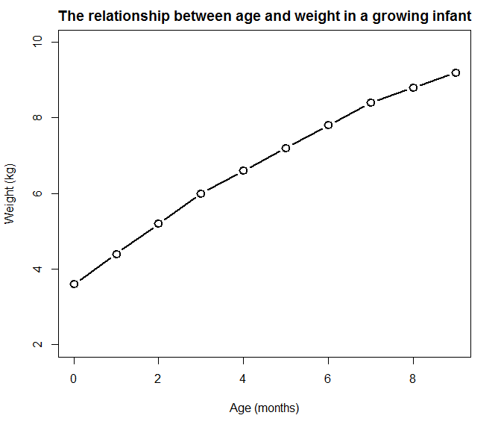
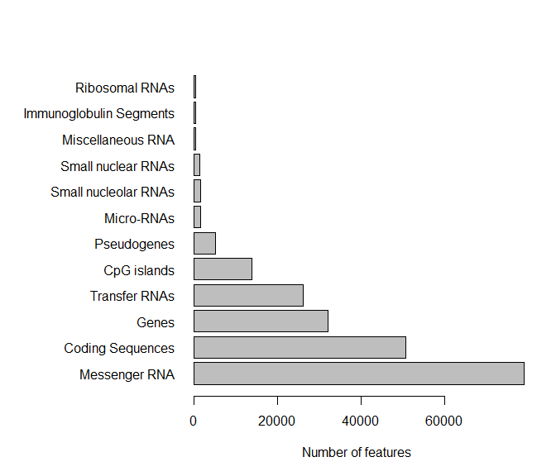
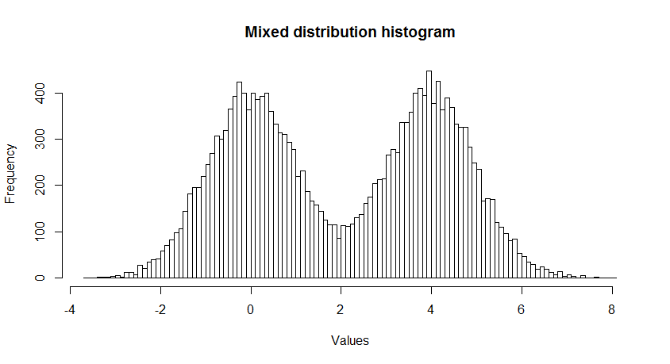

Exercise 2:
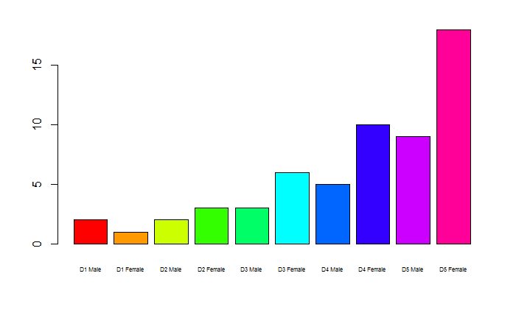
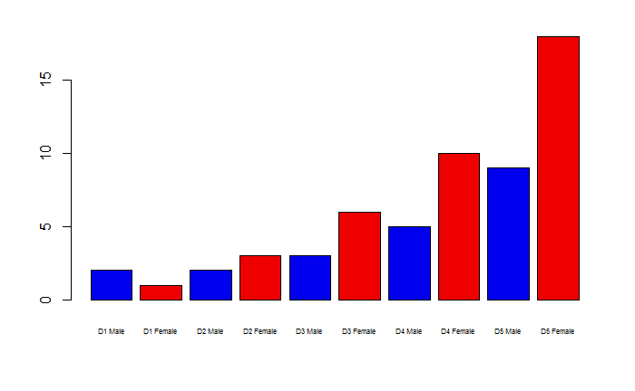
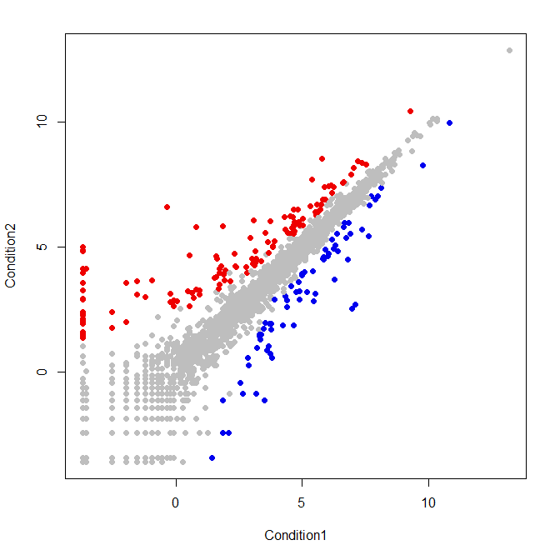
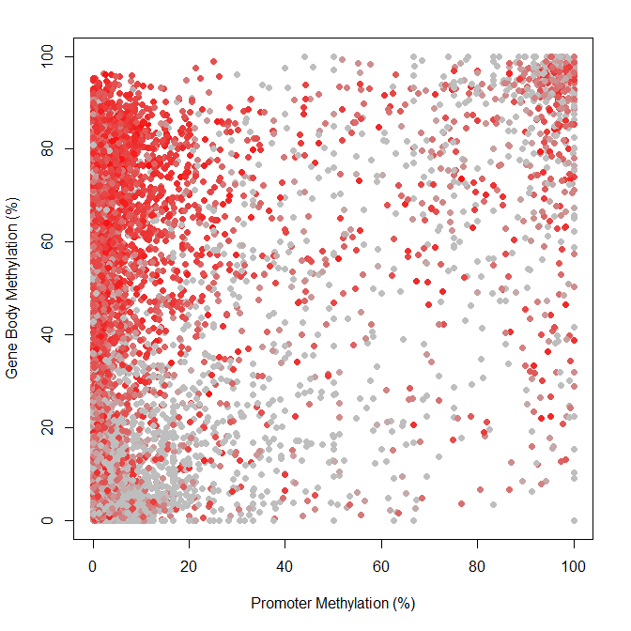

Exercise 3:
