Exercises:
Analysing ChIP-Seq data

Version 2021-04

Licence
This manual is © 2018-2021, Simon Andrews.

This manual is distributed under the creative commons Attribution-Non-Commercial-Share Alike 2.0 licence. This means that you are free:

- to copy, distribute, display, and perform the work

- to make derivative works

Under the following conditions:

- Attribution. You must give the original author credit.

- Non-Commercial. You may not use this work for commercial purposes.

- Share Alike. If you alter, transform, or build upon this work, you may distribute the resulting work only under a licence identical to this one.

Please note that:

- For any reuse or distribution, you must make clear to others the licence terms of this work.
- Any of these conditions can be waived if you get permission from the copyright holder.
- Nothing in this license impairs or restricts the author's moral rights.

Full details of this licence can be found at
http://creativecommons.org/licenses/by-nc-sa/2.0/uk/legalcode

Introduction
In this session we will go through the differential enrichment analysis of a ChIP-Seq experiment. This will include:

- Quality control
- Peak Calling
- Quantitation and Normalisation
- Differential enrichment analysis and validation of results.

Software
The software which will be used in this session is listed below. Software which requires a linux environment is indicated by an asterisk*:

- SeqMonk (http://www.bioinformatics.babraham.ac.uk/projects/seqmonk/)
- R (https://cran.r-project.org/)
- LIMMA (https://www.bioconductor.org/packages/release/bioc/html/limma.html)

Data
The data in this practical comes from GEO accession GSE69646 and represents CTCF ChIP from Naïve and Primed Embryonic Stem cells and their accompanying inputs.

The data has already been mapped to the GRCh38 genome using bowtie2 and was imported into seqmonk using the default import parameters (a MAPQ filter for >=20). All reads were extended by 250bp to more closely reflect the true insert size of the data.

Exercise 1: Quality Control
If you have data open in seqmonk already then close and re-open the program. Load in the seqmonk project file from the Human CTCF data folder.

Step 1.1
Using what you learned in the previous exploration exercise, look at the data presented here. The project has already had 500bp probes tiled over the genome and a linear read count quantitation has been performed (you can repeat this part if you like). Try to answer the following questions.

- Does the data show obvious enrichment?
- Do the enriched regions show a characteristic pattern of strand bias in the reads? If not, why not?
- Is there any evidence for PCR duplication in the samples?
- Do the inputs look similar enough to each other that we can consider them together rather than separately?
- Are there regions which appear to be enriched in the input sample? If so could you identify them?
- In the ChIP samples are the enriched regions similar in both samples? Is the level of enrichment similar across all samples? If not, does it group by condition?
- Are the peaks narrow or broad in nature?
- Are the peaks associated with any particular feature? Could we use features to quantitate the data or should we peak call?

Exercise 2: Peak Calling
In this study you can hopefully see that peak calling, specifically narrow peak calling, would be appropriate. We are going to look at two aspects of peak calling. We will start by doing a manual peak calling for one of the samples using the MACS peak caller built into seqmonk.

For a final analysis we will import a set of MACS2 peaks called on the command line from the underlying BAM files and will import these to create a merged set of peaks which we can then quantitate and analyse.

Step 2.1
We will use the MACS peak caller probe generator within seqmonk to call peaks for one of the samples so you can see how the process works. We’ll use the Naïve CTCF R1 sample.

To generate the peak lists go to Data > Define Probes > MACS Peak Caller.

In the options, the ChIP store will be the Naïve CTCF R1 sample which you want to analyse. The Input Store will be the Input Replicate Set (coloured purple) which will contain the reads from both input samples. You can leave the p-value and fragment size options set to their defaults.

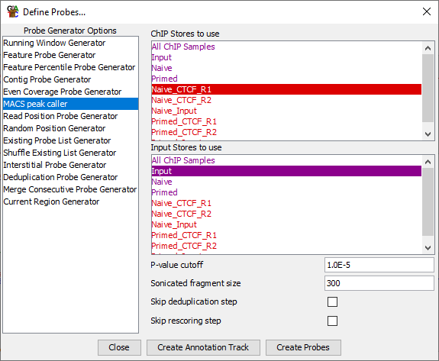

After creating the probes you can use a linear read count quantitation to quantitate them. After each call have a look at the positions which have been called and see if you agree with the decisions which were made by the caller.

Find some locations where you don’t see consistent peak calls across both replicate sets. Is there no enrichment at all in the samples where a peak wasn’t called?

Step 2.2 Importing MACS2 Peaks
We now want to make a final set of positions which we can analyse to compare enrichment between naïve and primed. You have been provided with a set of peak call files from MACS2 which were run on the underlying BAM files for this data.

naive_1_peaks.narrowPeak.txt
naive_2_peaks.narrowPeak.txt
primed_1_peaks.narrowPeak.txt
primed_2_peaks.narrowPeak.txt

We are going to import these peaks as annotation tracks and then create a merged set of peaks from them.

To import the peaks select:

File > Import Annotation > Text (Generic)

Then select all of the narrowPeak files from the MACS2_Peaks folder. You will then see a preview of the top of the first file and you’ll need to say which columns are the chromosome, start and end. These are chromosome = col 1, start = col 2, end = col3

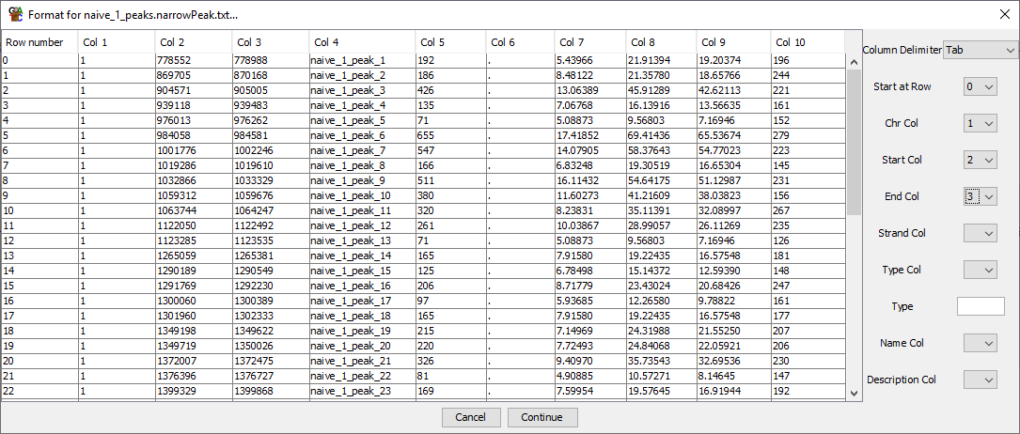

You can then press “Continue” until all of the peak sets are imported. Since you’re importing multiple annotation tracks they won’t automatically be added to your view. To make them appear you need to select.

View > Set Annotation Tracks

Then select the 4 peak tracks from the Available Tracks and add them to the displayed tracks. You should see them show up in the chromosome view.

Have a look at the sets of calls. Do you see the same positions coming up between the replicates for each condition? Do you see differences between naïve and primed?

Do you always see what you’d think was a biologically relevant enrichment increase where you have a call?

Do you see obvious differences in the enrichment between samples where you have differences in the presence / absence of a call in different samples?

Step 2.3 Creating a merged peak set
We now want to make a merged set of peaks from all of the predictions. We’ll need to do this in two steps.

Firstly we will use the feature probe generator to put probes over all of the peaks. To do this select:

Data > Define Probes > Feature Probe Generator

Select all 4 peak tracks in the “Features to design around” list and press create probes.

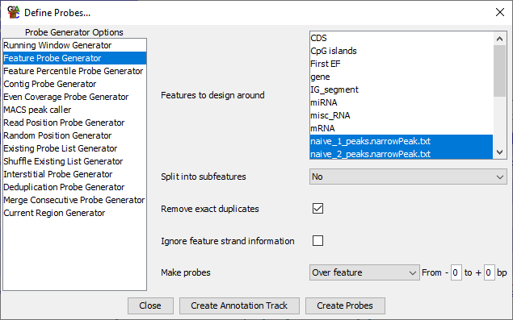

Use the “Fixed value quantitation” to give a value of 1 to each probe (these probes aren’t going to be around for long so it really doesn’t matter what quantitation they get!).

Next we need to merge overlapping peaks together. To do this select

Data > Define Probes > Deduplication Probe Generator

You can run the generator on its default settings which will just merge together any overlapping probes. Since our probes do not have any directionality (which is why they’re all grey in the display) the option to merge strands separately doesn’t do anything.

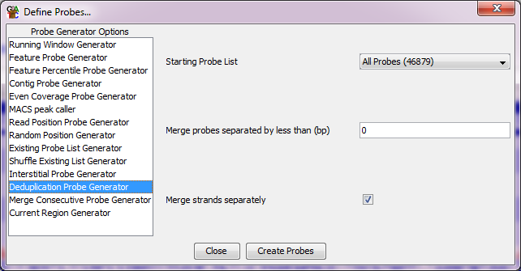

When the quantitation options appear again you should quantitate with read count quantitation on a log scale.

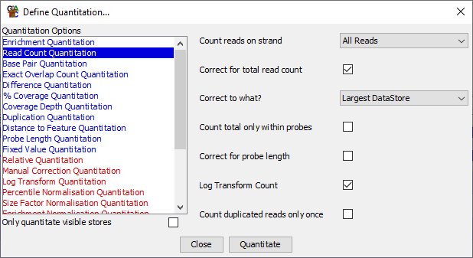

Look carefully through your final set of peaks. Compare it to the individual peak tracks you have for each sample, and the data you can see and check that it looks like you have captured all of the potentially interesting places in the genome.

You can also have a look at a scatterplot of the 3 groups of samples against each other – comparing the inputs to each of the ChIPs and the two ChIPs against each other.

Exercise 3: Filtering, Quantitation and Normalisation

Step 3.1
Before we go any further we’ll do one little bit of cleaning. If you find the Input Replicate set in the Data View and right click on it and select “Probe Value Histogram” you should see something like this:

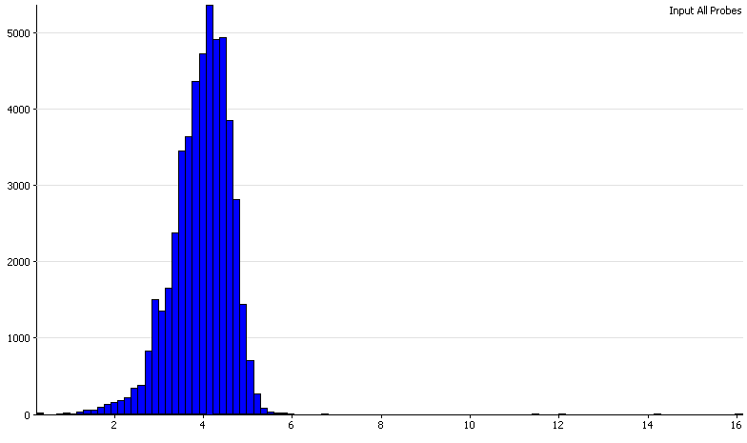
What this says is that most input regions (as expected) have relatively low and consistent values. However there are a small number of input regions with very (and in some case stupidly) high read counts. Most of these come from the mitochondrion, but there are others. Since they will skew our plotting it makes sense to get rid of them. We wouldn’t want to pursue hits with odd input read levels anyway.

To get rid of these select:

Filtering > Filter on Values > Individual Probes

You can then select only the probes with input values below 6

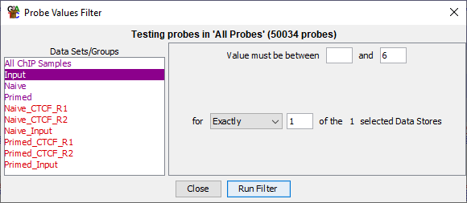

Save this list as “Sensible Input” and then select it to show only those probes.

Step 3.2 Quantitation Consistency Assessment
Now we want to quantitate and normalise the values for each peak so that they are directly comparable. This will also allow us to assess whether there is a biologically relevant difference in overall enrichment between the samples.

You should already have your peaks quantitated by a log read count quantitation, but if not you can do that now under Data > Quantitate Existing Probes > Read Count Quantitation.

To look at the overall enrichment you can draw a Cumulative Distribution Plot (Plots > Cumulative Distribution Plot). You should expect to see a large difference between the inputs and the ChIPs, but do all of the ChIPs look equally enriched? If not then is the enrichment linked to the condition?

You can also use a scatterplot (Plots > Scatterplot) to look at the relationship between the different ChIP samples to try to confirm what you see in the distribution summary plots.

Step 3.2 Quantitation Normalisation
You should have seen that there is a substantial difference in overall enrichment between the naïve and primed samples. This is probably a real biological difference and with more replicates we could build a very convincing case that the overall enrichment changes. Since we only have 2 replicates then this result may just be indicative, but this is likely the largest biologically relevant difference in these samples.

However, we also want to know if there are particular peaks which change in an unusual way given the overall differences between the samples. We therefore want to normalise away the global changes we see so that we can more directly do a positional analysis.

To do this we are going to use the enrichment normalisation quantitation. This sets two points of reference – a lower one for a background level, and an upper one for a highly enriched region. The tool then scales all samples between these two points.

The first thing we need to do is get rid of the input samples, since we don’t want to normalise those, so use View > Set Data Tracks to remove them from the current view.

We can then normalise the remaining 4 ChIP samples. Select

Data > Quantitate Existing Probes > Enrichment Normalisation Quantitation.

We are going to normalise between the 20th and 90th percentiles. Have a look back at the cumulative distribution plot and make sure you understand why these particular values were chosen.

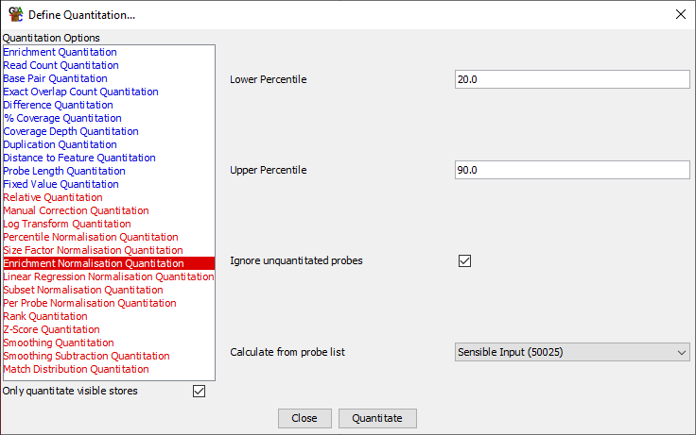

Note that we tick the box which says “Only quantitate visible stores” so that we don’t change the input samples (which you should have removed from the view earlier).

Once the data has been normalised plot the Cumulative Distribution Plot again and see if the data looks better matched now. You can also do a scatterplot between the naïve and primed replicate sets to check that the values are now directly comparable. When looking at the plot see if you think there is an obviously separate group of points which are behaving differently between the samples, or whether you’re just looking at degrees of enrichment difference.

Step 3.3 Viewing the normalised data
Now that we have values which are more directly comparable you can go back to re-draw the scatterplot of the native vs primed. Have a look and see if the data appears to be well normalised now. See if you think there will be large or small number of hits.

Have a look at some of the largest changes and get a feel for what these look like in the real data.

Exercise 4: Differential Enrichment Analysis

Step 4.1 LIMMA statistical testing
Since we are no longer working with raw counts but have applied a more complex normalisation to the data we don’t have the option of using count based statistics such as DESeq or EdgeR. If our samples had been better matched we could have done a raw, uncorrected count and then used these tools.

As it is since we are effectively working with continuous data we can use the LIMMA tool to find differentially enriched regions.

To do this select:

Filtering > Filter by Statistical Test > Continuous value statistics > Replicated Data > LIMMA. If you are using your filtered set of peaks (which you should) then you will get a warning saying:

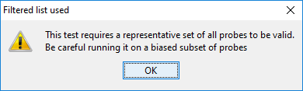

This would be a problem if the filtering we’d done was related to the difference between the samples, but in our case the filtering is on an independent factor so we can ignore the warning this time around.

To run the filter you simply need to select the two replicate sets (Naïve and Primed) and then press “Run Filter”.

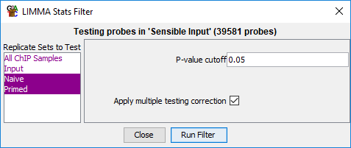

Save the list of hits you get.

Exercise 5: Validating and exporting peak locations

Step 5.1
The first thing to check is that the peaks which were selected by the statistics make sense. We can do a number of sanity checks on them.

Firstly we can highlight the LIMMA hits on a scatterplot of Naïve vs Primed. We should see that the hits fall on the outside of the cloud of points. You can double click on some of the more extreme points on the outsides of the distribution to see what the differences look like in terms of the raw data. Do you see a similar size of effect for peaks which increased and decreased? If not, why might this be?

You will see that you get a large number of hits from the analysis. If you wanted to focus on the most promising ones you could do additional filtering:

- FDR filtering to select peaks with a more stringent cutoff
- Value filtering to remove peaks with lower levels of observation
- Fold change filtering to remove peaks with lower levels of absolute enrichment
- Intensity difference filtering to select peaks with the highest enrichment relative to their observation level.

Step 5.2 Exporting Peaks
Finally, we are going to export a table of the hits we selected which we could take off for further analysis. We’re going to annotate them with the name of the closest gene, but you should be very careful in using such gene lists in any gene set analysis since our preliminary evaluation showed there wasn’t a strong linkage between the position of peaks and genes. We could however look for conserved sequence motifs in the selected regions to see if a sequence based rationale for the selection of the regions could be found.

To generate a report of the hit locations first select the LIMMA hit list in the Data view. Then select:

Reports > Annotated Probe Report.

We are going to annotate with the closest gene to each hit (up to 2kb away).

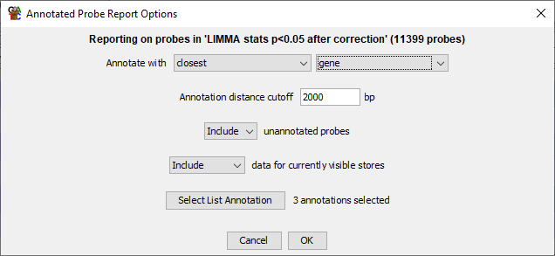

As well as being able to save the final list of interesting peaks to a text file, you can also use this display to order the peaks by their FDR value, so you can look at the most significant peaks.

Example Plots
So you know what you should be seeing here are copies of the plots you should generate in this practical:

Step 2.3 Merged Peaks
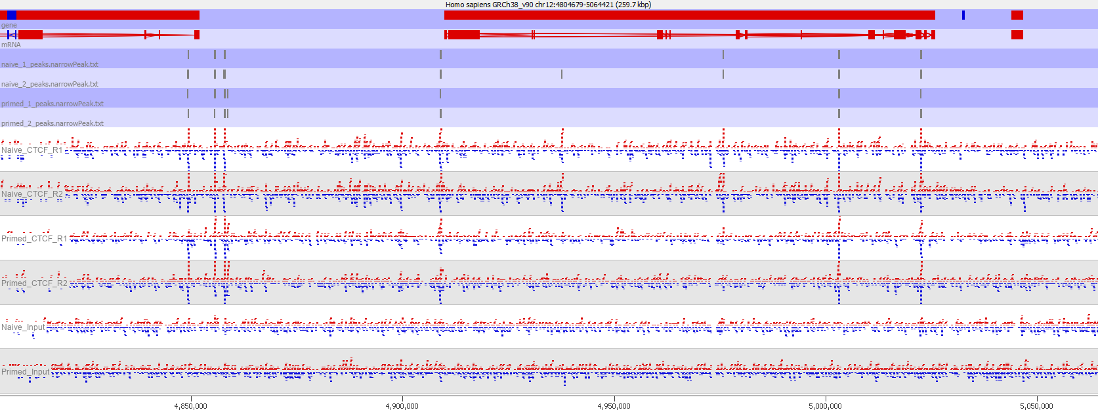

Step 2.3 Raw Quantitation Comparison

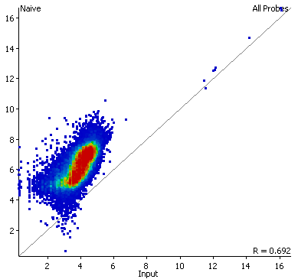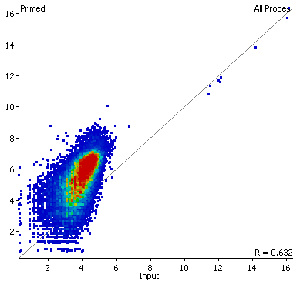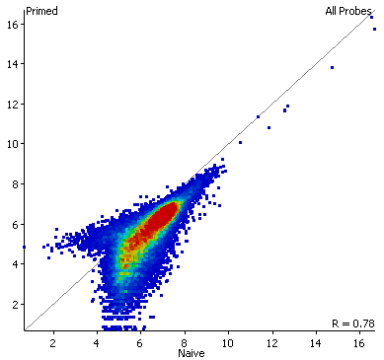

Step 3.2 Cumulative distribution plot before normalisation
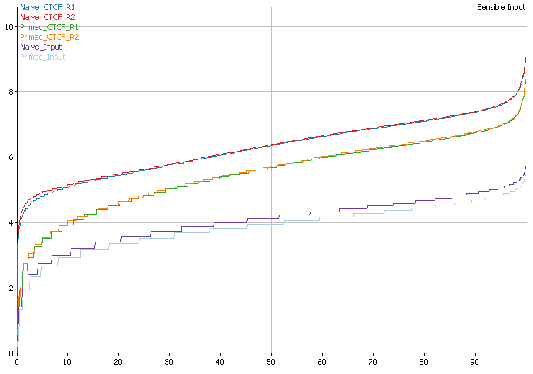

Step 3.2 Cumulative distribution plot after enrichment normalisation

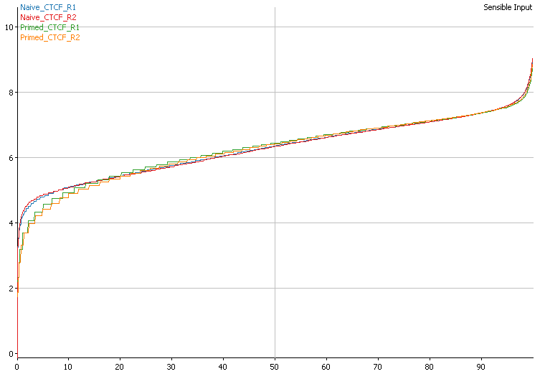

Step 3.2 Scatterplot after enrichment normalisation
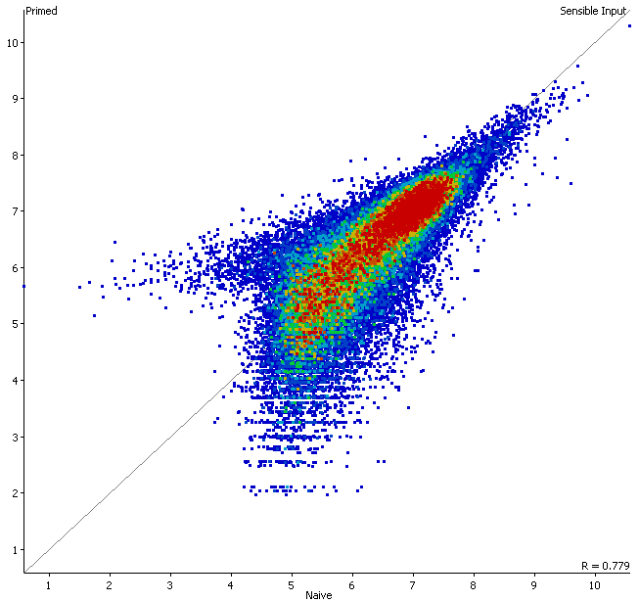

Step 5.1 LIMMA hits mapped onto a scatterplot
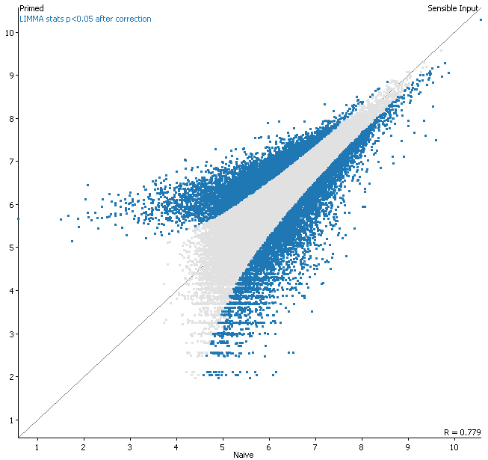

Step 5.2 Exported table of hits
