Exercises:

Using OneNote

as a

Laboratory Notebook

Version 2019-09

Introduction
In this practical we will work through some of the relevant basic features of OneNote for use as an electronic laboratory notebook.

Software
This practical is based on Microsoft Office’s OneNote and the instructions are based on the desktop PC version OneNote 2016 (although specific differences in the browser version, mac version and Office 365 version are all given and explained).
- OneNote (browser version, OneDrive, Office online)
- OneNote (Office 365)
- OneNote 2016
- OneNote App (Apple and android)

Data
All of the input data and files used in this practical can be downloaded from the Babraham bioinformatics web site (http://www.bioinformatics.babraham.ac.uk/training.html).

Licence
This manual is © 2019, Jo Montgomery.
This manual is distributed under the creative commons Attribution-Non-Commercial-Share Alike 2.0 licence. This means that you are free:
- to copy, distribute, display, and perform the work
- to make derivative works

Under the following conditions:
- Attribution. You must give the original author credit.
- Non-Commercial. You may not use this work for commercial purposes.
- Share Alike. If you alter, transform, or build upon this work, you may distribute the resulting work only under a licence identical to this one.

Please note that:
- For any reuse or distribution, you must make clear to others the licence terms of this work.
- Any of these conditions can be waived if you get permission from the copyright holder.
- Nothing in this license impairs or restricts the author's moral rights.

Full details of this licence can be found at
http://creativecommons.org/licenses/by-nc-sa/2.0/uk/legalcode

Exercise 1:

Accessing the Electronic Laboratory Notebook (ELN) area on Sharepoint

If your Group Leader has already requested a Group ELN, there will already be a section and you should have a folder. If not, we will go through this procedure quickly and will access the desktop version of OneNote directly to carry out the remainder of the exercises and you can come back to this once you have the Group ELN in place on Sharepoint.
Go to https://babraham.sharepoint.com/sites/ELN/SitePages/Home.aspx
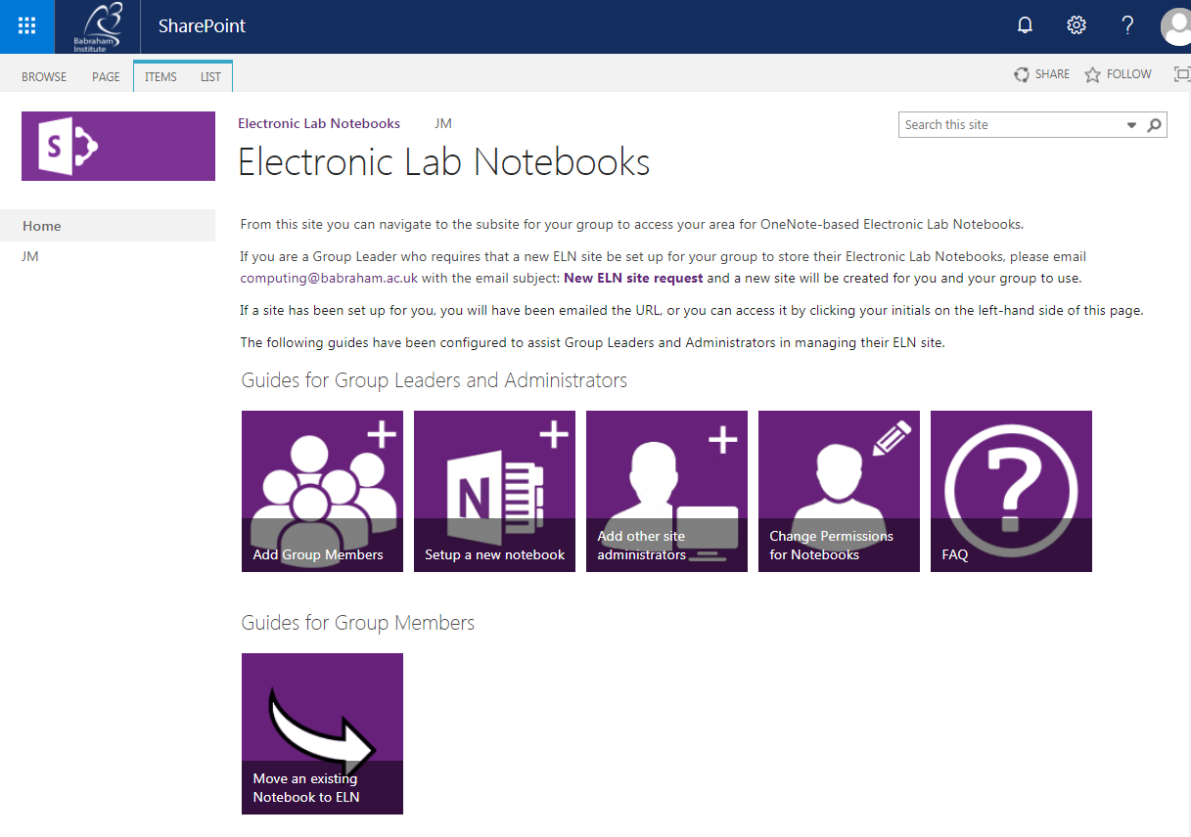
And navigate to your Group area as indicated by your Group Leader’s initials on the left hand menu.
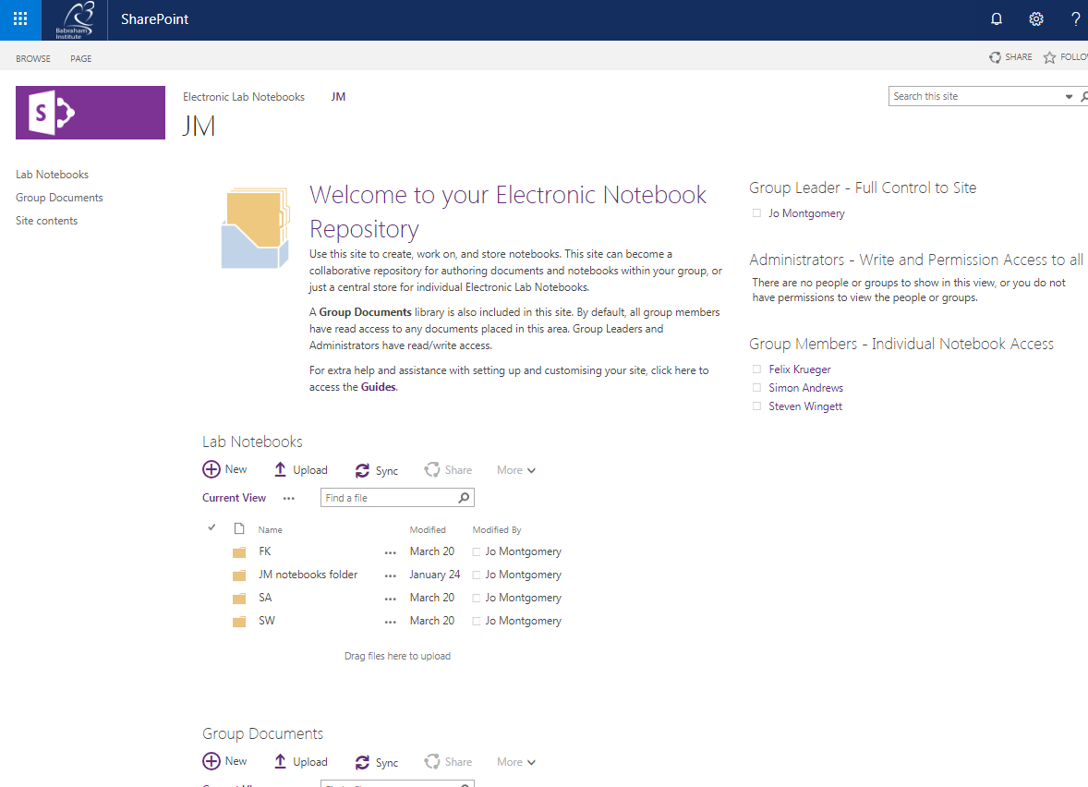

You will then see a Group directory called Lab Notebooks. Depending on read/write Permissions you will see a number of folders here. There should be one for each member of the group. See the ELN page for tutorials from computing on how to add members and change permissions as well as FAQs.
Click on your folder and you will see a list of your notebooks.
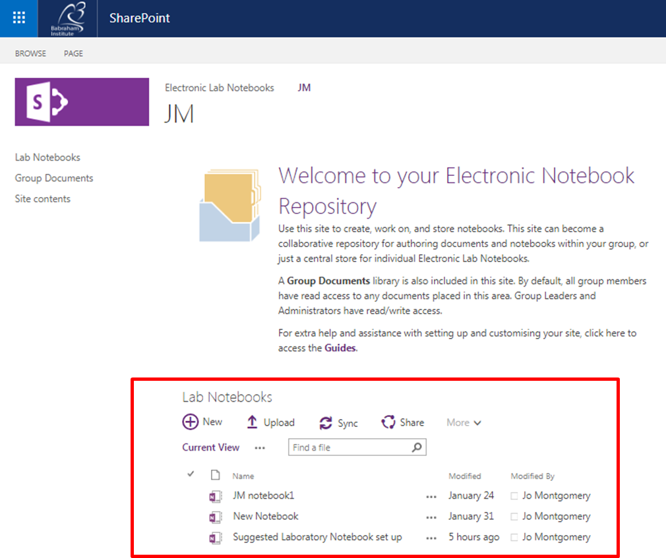
Open the notebook (OneNote Online)
NB If you don’t yet have this set up for your group, we will run this course directly in Office 365 online or in the desktop version of OneNote.

Exercise 2:

Setting up the notebook

Create a notebook that looks like this, with these:

- section names
- tab colours
- pages
- page names
- subpages

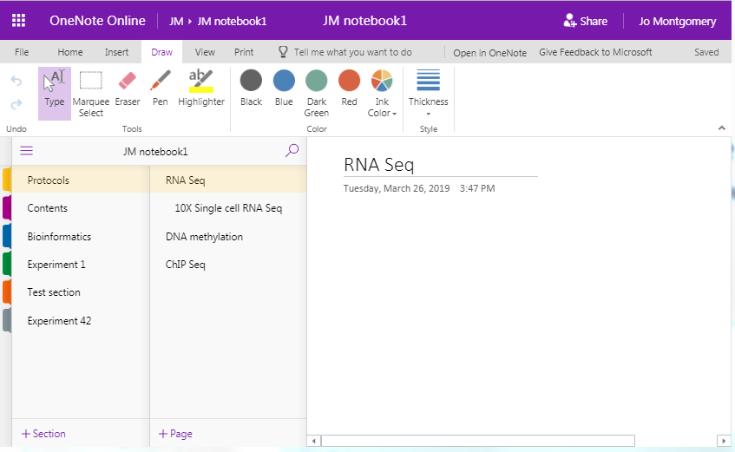

Exercise 3:

Adding text, tables, formatting and images
Create a page that looks like this with:
- a similar layout and information
- text (this can be any text – just play about with fonts, sizes etc),
- table
- formatting
- images - try inserting an image from file (see course data) and also searching for images online.
- note the text styles in the Protocol.

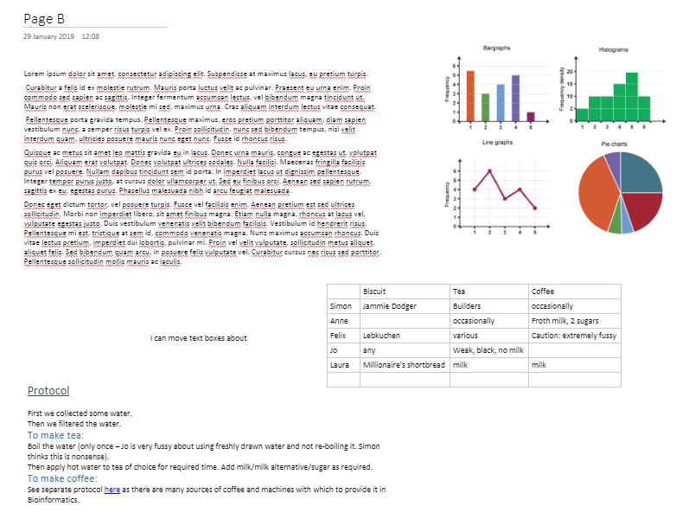

Exercise 4:

Adding files and links
You will find files in the course data file.

- Add an excel file as an attachment
- Add a word document as a file printout.
- Insert a link to a webpage.
- Create a link to another page of your notebook.
- Using copy to path, create a non-dynamic link to a file in a saved location.

- In the finder/document library, Shift + right click on a file of your choice and select
copy as path.
- Paste this path into OneNote – this is just a reference to the location
- Can you make it a functional link to take you to that file location?

Exercise 5:

Other useful tools
- Go to the Draw menu and select a pen type, thickness and colour. Draw a flower with at least 3 colours/pen thicknesses/types.
- Insert a gel image or powerpoint slide screenshot and annotate (see course data folder).
- Create a to-do list with at least 3 different functions (eg flag for follow up, mark as a question, highlight, mark as completed etc). Explore the options available.
- Create a table of contents using your insert link skills
- Search the text for a word you know you’ve included – you can search by section or page in OneNote online.

Exercise 6:

Sharing your Laboratory Notebook
Share a notebook with someone in the room – check they can see your notebook.
Open a shared notebook – make a new tab and type them a message.
Check you can receive the message in a new tab which someone has sent to you.
Can you track the changes to see when they were made and by whom? (Versions)
NB: You can use the View menu to access versions and authors.

Exercise 7:

Suggestions for setting up a OneNote notebook as a Laboratory Notebook
Put your new skills into practice: Now create a new notebook and set up a suitable layout and style for a basic laboratory notebook – new sections for separate projects/experiment types/mouse strains etc. as per your requirements. You don’t need to populate it with any real data but have a play inserting files or images, creating tables and anything else you think might be useful for you.
Take a look at this example laboratory notebook (link below), see how data is added and sections are organised etc. This is just an example. Your laboratory notebook needs to be flexible for you, your research and your group, so find the best set-up for you.

https://babraham.sharepoint.com/:o:/s/ELN/JM/EukJeoh_7qFFlhWye9y5K6QBtxshmDPJTPzk7kNN0eXYQg?e=ZZlyMR
or
https://tinyurl.com/labbooklayout

