Exercises:
QC and Mapping of
BS-Seq data
at the Babraham Institute

Version 1.2

22 May 2017

Licence
This manual is © 2014-17, Felix Krueger & Simon Andrews.

This manual is distributed under the creative commons Attribution-Non-Commercial-Share Alike 2.0 licence. This means that you are free:

- to copy, distribute, display, and perform the work

- to make derivative works

Under the following conditions:

- Attribution. You must give the original author credit.

- Non-Commercial. You may not use this work for commercial purposes.

- Share Alike. If you alter, transform, or build upon this work, you may distribute the resulting work only under a licence identical to this one.

Please note that:

- For any reuse or distribution, you must make clear to others the licence terms of this work.
- Any of these conditions can be waived if you get permission from the copyright holder.
- Nothing in this license impairs or restricts the author's moral rights.

Full details of this licence can be found at
http://creativecommons.org/licenses/by-nc-sa/2.0/uk/legalcode

Introduction
In this session we will use small subsets of publically available Bisulfite-Seq data in FastQ format, perform initial QC and trimming steps and align the data to the mouse genome. The basic steps we’re going to perform are:

- Initial quality control with FastQC
- Adapter and quality trimming using TrimGalore (wrapper around Cutadapt)
- Alignment of reads to the mouse genome using Bismark
- Deduplicate aligned data and extract methylation calls (used for analysis later on)
- Generate graphical HTML analysis report

Software
The data processing described in this practical is intended to be run as a set of command line tools and should work on Linux or Mac platforms.

- FastQC (http://www.bioinformatics.babraham.ac.uk/projects/fastqc/)
- TrimGalore (http://www.bioinformatics.babraham.ac.uk/projects/trim_galore/)
- Cutadapt (https://code.google.com/p/cutadapt/)
- Bismark (http://www.bioinformatics.babraham.ac.uk/projects/bismark/)
- Bowtie (http://bowtie-bio.sourceforge.net/)
- Bowtie2 (http://bowtie-bio.sourceforge.net/bowtie2/)

Data
The data in this practical comprises the first 200000 reads from a single-end data set (GSM1337541). The data used in this practical can be downloaded from the Babraham Bioinformatics web site (http://www.bioinformatics.babraham.ac.uk/training.html).

Preparations specific for use at BI:

MolBio Software Shortcut
If it is not already present, create a shortcut to MolBio software repository.

To do this, right click on an empty part of your desktop and select New>Shortcut. In the window that appears type the following path and click Next:
\\bi-fas1a\bioinfserv\Software\Shortcuts

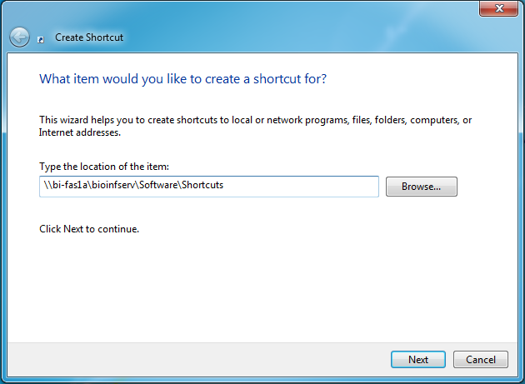

Give your shortcut a name (e.g. MolBio Software) and click on Finish

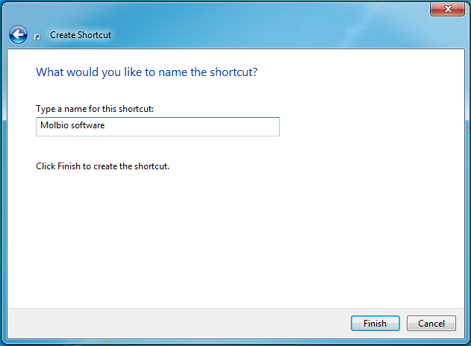

There should now be a folder on your desktop from which you can start the various MolBio programs

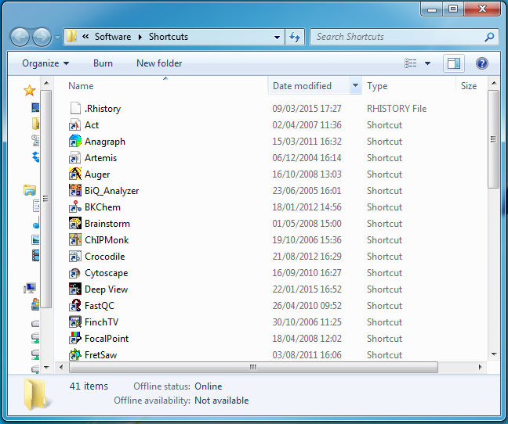

Log on to the Babraham Compute Cluster
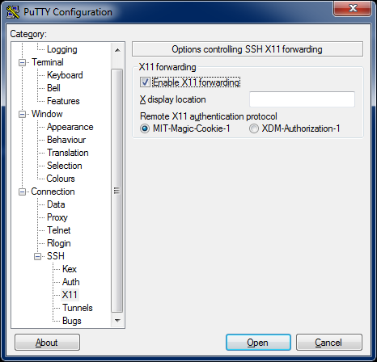
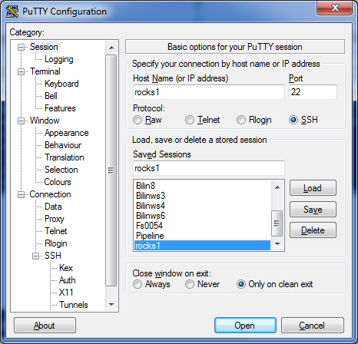
Open a new PuTTY session, enter rocks1 as the Host Name address, and make sure X11 forwarding is checked under Connection > SSH > X11.

Log on to rocks1 using your login credentials. You are now logged into the cluster and are in your home directory, e.g.
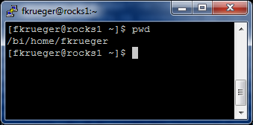
Since we are all logged on to the head node of rocks1 and we are running the same commands at the same time, some of which require several cores and up to 16GB of RAM, it would almost certainly require too many resources for the head node to handle. To avoid this, we are simply going to log in as as an interactive session using the command qlogin. Just type:
$ qlogin

In order to avoid duplication of the course data, you can create symbolic links to the data files in a new folder you can create with this command:
$ mkdir Meth_Course_Data

Next, move into the Course directory and use the following commands to make links to the tutorial files you will need today.
$ cd Meth_Course_Data/
$ ln -s /bi/scratch/Meth_Course_Data/QC_and_Mapping/*fastq.gz .
Please notice the . (dot) at the end!

List all the files in the directory:
$ ls -l

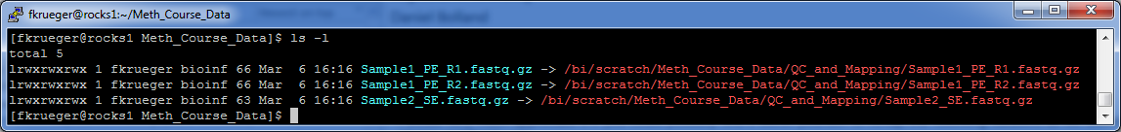

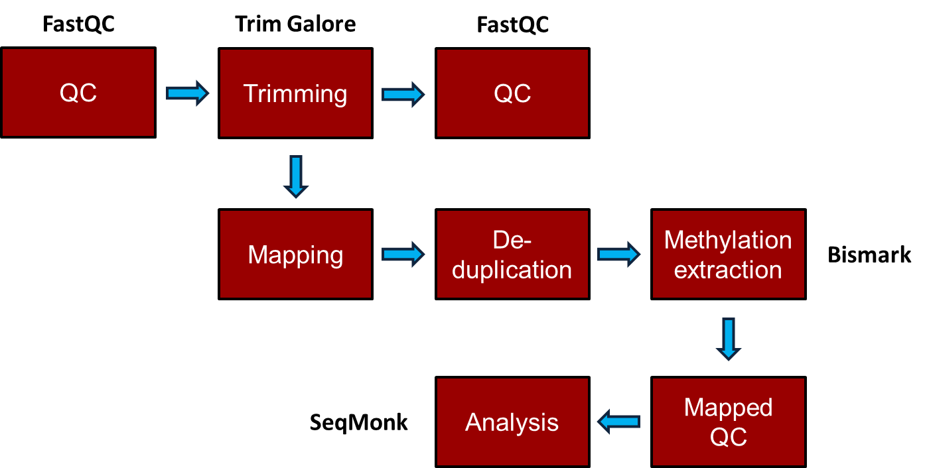
Exercise outline

Exercise 1 – Initial QC
The data for this section should be in the ~/Meth_Course_Data folder. You should be able to see three files in there:
$ cd ~/Meth_Course_Data
$ ls
Sample1_PE_R1.fastq.gz
Sample1_PE_R2.fastq.gz
Sample2_SE.fastq.gz

In this exercise, we are going to run a full primary analysis of bisulfite treated reads, starting from raw FastQ files as they might come off an Illumina sequencer from any sequencing facility. Since modern sequencers generate huge data volumes (~30M sequences for a MiSeq, ~200M for a lane on the HiSeq and ~450M for a NextSeq) the analysis of a full run may take up to a couple of days to complete (depending on several parameters such as read length, genome size, repeat content, alignment parameters etc).

The two files for Sample1 are Read 1 (R1) and Read 2 (R2) of a paired-end (PE) experiment. Sample2 is a single-end (SE) experiment.

First we would like to get an initial idea about the sequencing quality of the files we are going to use.
To run FastQC on the files you can use its interactive mode by typing:
$ module load fastqc
fastqc &
Then select files to be analysed within the FastQC program.

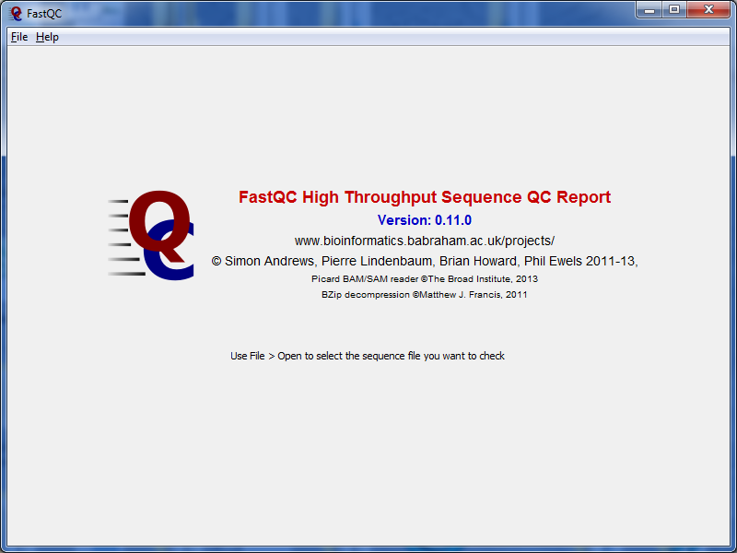

Alternatively, you can run FastQC on all samples in one go by using its non-interactive mode with the command:
$ fastqc *fastq.gz
Once the analysis has completed you can look at the html reports using Firefox, e.g.:
$ firefox Sample1_PE_R1_fastqc.html &

What can you tell about the files without knowing the origin of or having aligned the data? Try to find answers to the following questions:
- What does the sequence quality look like?
- Does the data appear to contain read-throughs into the Illumina adapter sequence?
- Are there overrepresented sequences/contaminants?
- Is there a noticeable difference between Read 1 and Read 2 for the paired-end experiment?
- Is there anything else you can spot from the QC reports that might affect subsequent steps?

Exercise 2: Adapter and quality trimming
In Exercise 1 we have seen that the sequencing quality in our test samples looks fairly good. Especially with longer reads or RRBS data one should still get into the habit of trimming the data to improve mapping efficiency and reduce the chance of misalignments.

First, load the Trim Galore module:
$ module load trim_galore

This command will also load the Cutadapt module for you so it should be ready to use.

Sample 1 is a paired-end experiment, so it is important to make this known to the trimming program with the option --paired:
$ trim_galore --paired --fastqc Sample1_PE_R1.fastq.gz Sample1_PE_R2.fastq.gz

This command automatically removes:
- base calls with a Phred score of 20 or lower (assuming Sanger encoding)
- any traces of standard Illumina adapter sequence from the 3' end
- Sequence pairs where either read became too short as a result of trimming (<20 bp)
- Keeps Reads 1 and Read 2 of sequence pairs in sync (required by all aligners)
From Exercise 1 we know that Sample2 looks like a single-end RRBS experiment. Trim Galore has an additional option (--rrbs) that aims to remove filled-in artificial cytosines at the 3’ end of reads. The command to be used is:
$ trim_galore --rrbs --fastqc Sample2_SE.fastq.gz

This command automatically removes:
- base calls with a Phred score of 20 or lower (assuming Sanger encoding)
- any traces of standard Illumina adapter sequence from the 3' end
- Sequences which became too short as a result of trimming (<20 bp)
- If adapter contamination is found, 2 additional base pairs are being removed from the 3’ end to remove unwanted artificially introduced unmethylated cytosine residues

Exercise 3: Read alignments using Bismark
Alignments and methylation calling are carried out with Bismark. The paired-end reads of Sample1 are aligned using Bowtie 2 because it scales much better for longer reads. The rather short single-end reads of Sample2 could also be aligned using Bowtie, but for convenience reasons we are also using Bowtie 2 (which is the default). The parameter --bam writes the output file in BAM format instead of an uncompressed SAM file, which might easily reach several hundred GB for currently produced sequencing files (not for our sample files though). The folder ‘/bi/scratch/Genomes/Mouse/GRCm38/’ already contains the reference sequence files for the mouse genome (GRCm38 build) as well as the bisulfite genome indexes for Bowtie and Bowtie 2, so we can use them straight away (the indexing of a human or mouse sized genome takes ~2 hours, so we have already prepared this in advance).

As always, you need to load the module you want to use
$ module load bismark

This command will also load the Bowtie, Bowtie2 and Samtools modules. All exercises from now on won’t require you to load any further modules.

To run Bismark for Sample 1 (paired-end), type:
$ bismark --genome /bi/scratch/Genomes/Mouse/GRCm38/ -1 Sample1_PE_R1_val_1.fq.gz -2 Sample1_PE_R2_val_2.fq.gz

To run Bismark for Sample 2 (single-end), enter:
$ bismark --genome /bi/scratch/Genomes/Mouse/GRCm38/ Sample2_SE_trimmed.fq.gz

The aligments should finish within a couple of minutes each. If you wanted to find out how well the alignment step went you can look at the Bismark mapping reports in the terminal window, like so:
$ cat Sample1_PE_R1_val_1_bismark_bt2_PE_report.txt
$ cat Sample2_SE_trimmed_bismark_bt2_SE_report.txt

Exercise 4: Deduplication
The deduplication is carried out using a script which is part of the Bismark package, called deduplicate_bismark. In its default mode it will use the first alignment for a given genomic region, which is basically equivalent to using a random alignment per position. The script works out whether the file to be deduplicated is a single-end or paired-end file. The parameter --bam ensures that the output file is a BAM file (and not an uncompressed SAM file).
$ deduplicate_bismark --bam Sample1_PE_R1_val_1_bismark_bt2_pe.bam

Note that Sample2 is an RRBS file and should not be deduplicated since this might remove a lot of valid alignments.

Exercise 5: Methylation extraction
Extracting methylation calls from the Bismark BAM files automatically generates a small report detailing the methylation calls that were found during the process (which might or might not look somewhat different to the stats in the Bismark mapping report, depending on whether or not the file was heavily duplicated). The methylation extractor also detects if the input file is a single-end or a paired-end file, and will set the option --no_overlap for paired-end files automatically. The option --bedGraph will produce the coverage files, which are very intuitive to read and will serve as input file for the R-package bsseq later in the differential methylation part of this course. The coverage files could also be submitted to GEO as processed data when it comes to publishing your data.

The methylation extractor command for Sample 1 is:
$ bismark_methylation_extractor --bedGraph --gzip Sample1_PE_R1_val_1_bismark_bt2_pe.deduplicated.bam

This command
- generates strand and context specific cytosine output files
- counts overlapping parts of read pairs only once
- generates an M-bias report
- produces a bedGraph and coverage file
- generates an overall count report for (splitting report)

The methylation extractor command for Sample 2 is:
$ bismark_methylation_extractor --bedGraph --gzip Sample2_SE_trimmed_bismark_bt2.bam

This command
- generates strand and context specific cytosine output files
- generates an M-bias report
- produces a bedGraph and coverage file
- generates an overall count report for (splitting report)

Exercise 6: Bismark HTML report
The module bismark2report generates a visual HTML report from the Bismark alignment, deduplication, methylation extraction and M-bias reports. It attempts to automatically detect all relevant files in the current working directory folder for you (which should work just fine here), but files may also be specified if desired. Just run:
$ bismark2report

The report is meant to get you an impression very quickly of how well the experiment has worked. To view the reports, type:
$ firefox Sample1_PE_R1_val_1_bismark_bt2_PE_report.html &
$ firefox Sample2_SE_trimmed_bismark_bt2_SE_report.html &

Take a look at the reports and try to answer the following questions:
- Was the mapping efficiency good or were there any major problems?
- Does the average methylation level look as expected?
- Can you comment and the level of bisulfite conversion efficiency in the samples? (You might want to look at the levels of non-CG methylation for this)
- Are there any notable technical methylation biases in the results? If so what might be the causes and what could you do to remove them?
The Bismark report should look something like this:

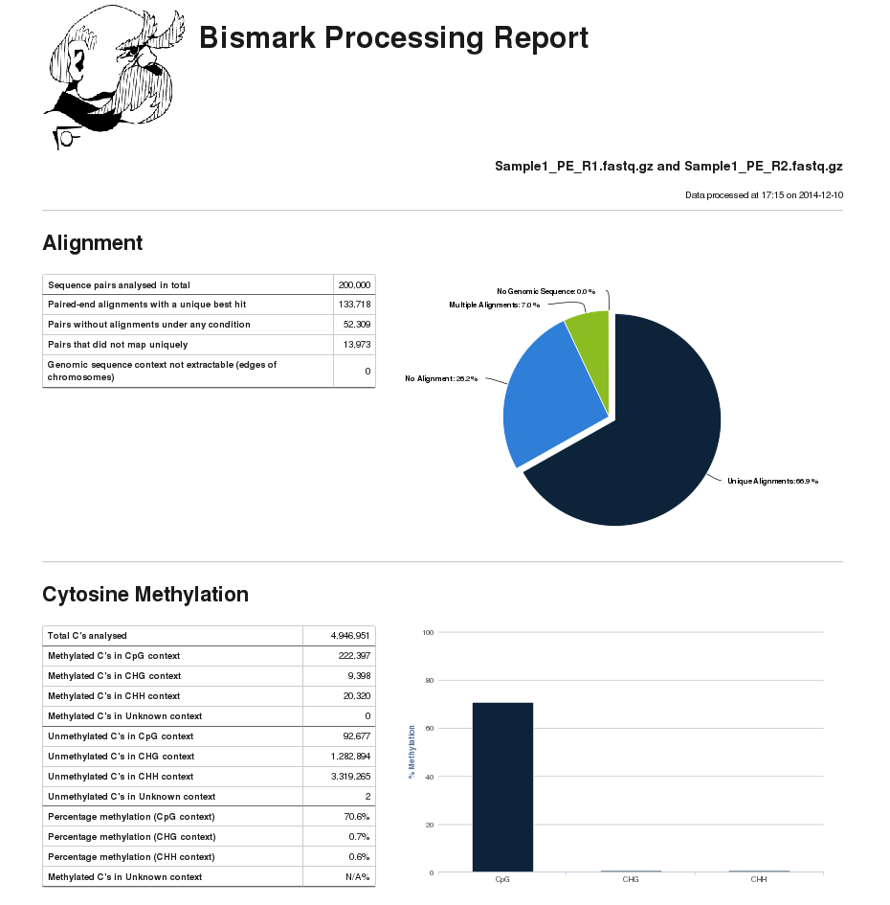

Exercise 7: Using ClusterFlow to run the entire Bismark work flow

At BI we are using ClusterFlow to stream line pipeline processing.
$ cf fastq_bismark --help

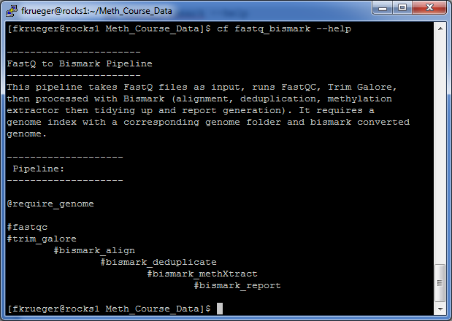

As you can see, this single command runs all the steps we have run manually above in a single pipeline, and sends you an email once everything has finished.

ClusterFlow can be used like this:
$ module load clusterflow

To set up ClusterFlow just once, you need to type:
$ cf --setup
Basically, just enter your email address and use the defaults for everything else.

Now you are ready to use ClusterFlow, this time however you do NOT need to run “qsub … command”

$ cf fastq_bismark --genome GRCm38 Sample1_PE_R1.fastq.gz Sample1_PE_R2.fastq.gz

or

$ cf fastq_bismark --genome GRCm38 Sample2_SE.fastq.gz

