Exercises:

Sample Size estimation

Version 18.04

Licence
This manual is © 2015-2018, Anne Segonds-Pichon.

This manual is distributed under the creative commons Attribution-Non-Commercial-Share Alike 2.0 licence. This means that you are free:

- to copy, distribute, display, and perform the work

- to make derivative works

Under the following conditions:

- Attribution. You must give the original author credit.

- Non-Commercial. You may not use this work for commercial purposes.

- Share Alike. If you alter, transform, or build upon this work, you may distribute the resulting work only under a licence identical to this one.

Please note that:

- For any reuse or distribution, you must make clear to others the licence terms of this work.
- Any of these conditions can be waived if you get permission from the copyright holder.
- Nothing in this license impairs or restricts the author's moral rights.

Full details of this licence can be found at
http://creativecommons.org/licenses/by-nc-sa/2.0/uk/legalcode

Exercise 1:
(Data from: http://www.sciencealert.com/scientists-are-painting-eyes-on-cows-butts-to-stop-lions-getting-shot)

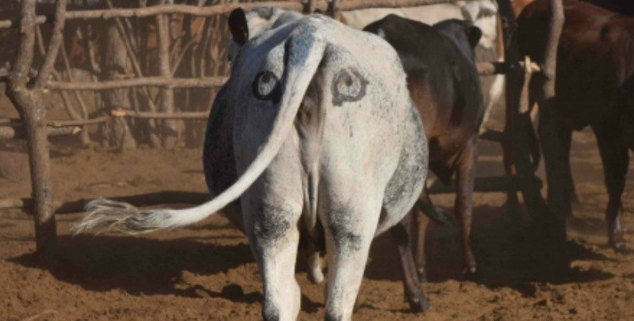

Scientists have come up with a solution that will reduce the number of lions being shot by farmers in Africa - painting eyes on the butts of cows. It sounds a little crazy, but early trials suggest that lions are less likely to attack livestock when they think they’re being watched - and less livestock attacks could help farmers and lions co-exist more peacefully.

Pilot study over 6 weeks: 3 out of 39 unpainted cows were killed by lions, none of the 23 painted cows from the same herd were killed.
- Do you think the observed effect is meaningful to the extent that such a ‘treatment’ should be applied? Consider ethics, economics, conservation …
- Run a power calculation to find out how many cows should be included in the study (assume a balanced design).
- Unbalanced design: estimate samples sizes of the unpainted group was 2.5 bigger than the painted one

Exercise 2:
(Data from ‘Discovering Stats with SPSS’ by Andy Field)

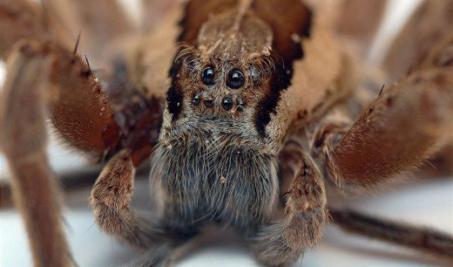

Pilot study: 10 arachnophobes were asked to perform 2 tasks:
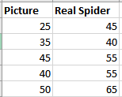
Task 1: Group1 (n=5): to play with a big hairy tarantula spider with big fangs and an evil look in its eight eyes.
Task 2: Group 2 (n=5): to look only pictures of the same hairy tarantula.

Anxiety scores were measured for each group (0 to 100).
- Enter the data (Excel) so that you can extract the values for a power calculation
- Run a power calculation (assume balanced design and parametric test)
- On second thought, scores are often non-normally distributed and a non-parametric approach might be more appropriate. Estimate the new sample sizes.

