Exporting Files (v2.0)

Know your file types:
Vector File Types | Bitmap File Types
.svg | .png
.eps | .jpg / .jpeg
.pdf | .gif
.ai | .bmp
 | .tif / .tiff

Choosing between vectors and bitmaps
Broadly speaking, vectors should be used for anything that has been generated by a computer – typically graphs, illustrations and text. Figure components that have been generated by a camera such as microscopy images or blot photos should be kept as bitmaps.

Vectors have another trick up their sleeve too – bitmap images can be embedded within a vector image. This is how all publication figures should be created: vector graphics for assembly and annotation of figure panels with any bitmap images embedded within.

Exporting vector files from common programs
Excel - Move/copy your plot to its own worksheet, then File > Save As and choose PDF file format

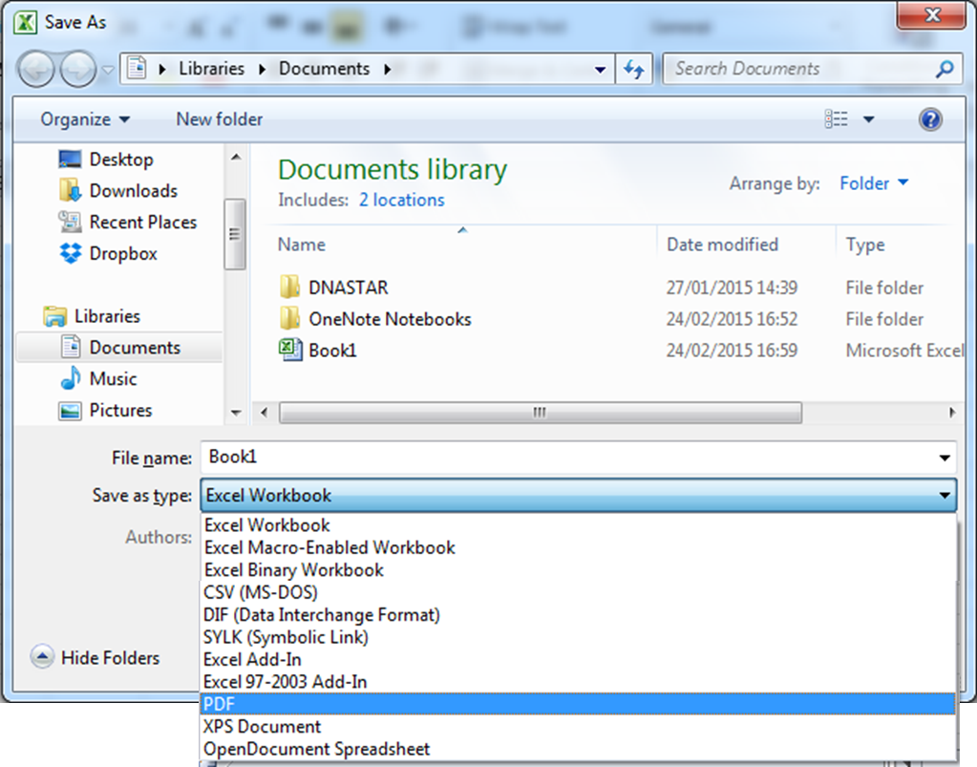

R / RStudio – Plots can be saved as SVG files

R:
setwd("D:/")
svg(filename = "my_plot.svg",width=5,height=5)
plot(1:10,sqrt(1:10),pch=19)
dev.off()

RStudio:

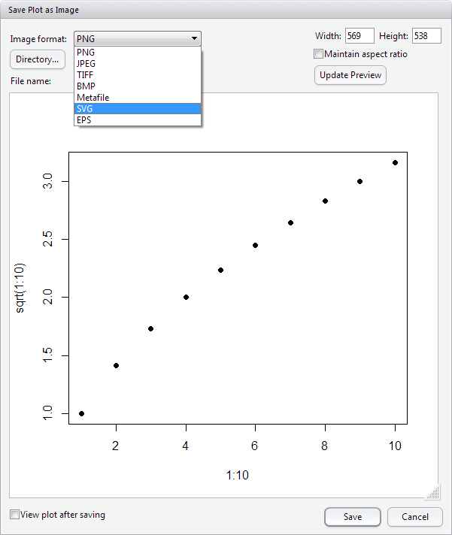

SeqMonk – Choose SVG as the File Format when saving plots

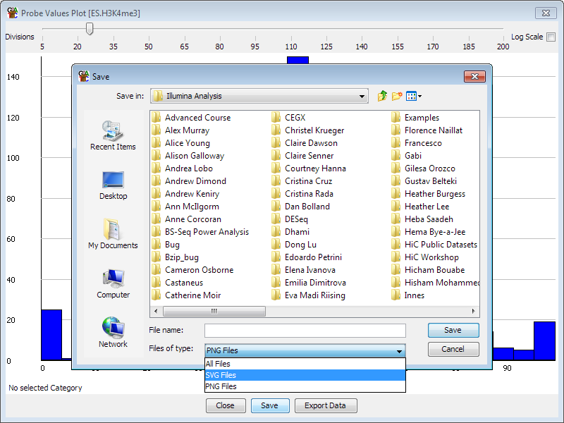

GraphPad Prism – File > Export As, and choose PDF as the File Format

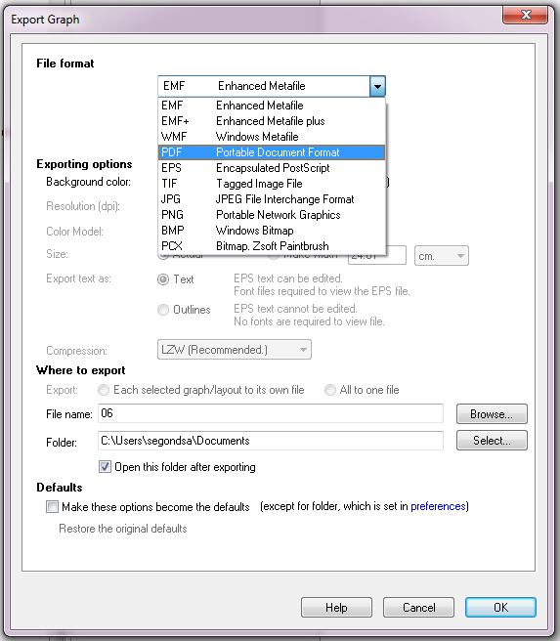

FlowJo -Choose SVG as the File Format when saving plots

