Exercises:
QC and Mapping

of

BS-Seq data

Version

2021-04-AWS

Licence
This manual is © 2014-21, Felix Krueger & Simon Andrews.

This manual is distributed under the creative commons Attribution-Non-Commercial-Share Alike 2.0 licence. This means that you are free:

- to copy, distribute, display, and perform the work

- to make derivative works

Under the following conditions:

- Attribution. You must give the original author credit.

- Non-Commercial. You may not use this work for commercial purposes.

- Share Alike. If you alter, transform, or build upon this work, you may distribute the resulting work only under a licence identical to this one.

Please note that:

- For any reuse or distribution, you must make clear to others the licence terms of this work.
- Any of these conditions can be waived if you get permission from the copyright holder.
- Nothing in this license impairs or restricts the author's moral rights.

Full details of this licence can be found at
http://creativecommons.org/licenses/by-nc-sa/2.0/uk/legalcode

Introduction
In this session we will use small subsets of publicly available Bisulfite-Seq data in FastQ format, perform initial QC and trimming steps and align the data to the mouse genome. The basic steps we’re going to perform are:

- Initial quality control with FastQC
- Adapter and quality trimming using Trim Galore (a wrapper around Cutadapt)
- Alignment of reads to the mouse genome using Bismark
- Deduplicate aligned data and extract methylation calls (used for analysis later on)
- Generate graphical HTML analysis report

Software
The data processing described in this practical is intended to be run as a set of command line tools and should work on Linux or Mac platforms.

- FastQC (http://www.bioinformatics.babraham.ac.uk/projects/fastqc/)
- Trim Galore (http://www.bioinformatics.babraham.ac.uk/projects/trim_galore/)
- Cutadapt (https://code.google.com/p/cutadapt/)
- Bismark (http://www.bioinformatics.babraham.ac.uk/projects/bismark/)
- Bowtie2 (http://bowtie-bio.sourceforge.net/bowtie2/)

Data
The data in this practical comprises 200,000 reads from a paired-end dataset (GSM1027571). The data used in this course may be downloaded from the Babraham Bioinformatics web site (http://www.bioinformatics.babraham.ac.uk/training.html).

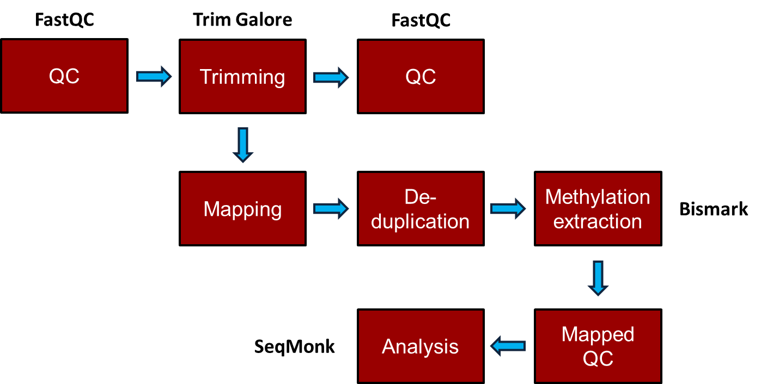
Exercise outline

We will talk you through a way to connect to connect to a server on the AWS (Amazon Web Services) before this practical.

Exercise 1 – Initial QC
The data for this section is in the QC_and_Mapping subfolder of your main Meth_Course_Data data folder. You should be able to see two files in there:

$ cd Meth_Course_Data
$ cd QC_and_Mapping
$ ls
Sample1_PE_R1.fastq.gz
Sample1_PE_R2.fastq.gz

In this exercise, we are going to run a full primary analysis of bisulfite treated reads, starting from raw FastQ files as they might come off an Illumina sequencer from any sequencing facility. Since modern sequencers generate huge data volumes (~30M sequences for a MiSeq, ~200M for a lane on the HiSeq and ~450M for a NextSeq) the analysis of a full run may take up to a couple of days to complete (depending on several parameters such as read length, genome size, repeat content, alignment parameters).

The two files for Sample1 are Read 1 (R1) and Read 2 (R2) of a paired-end (PE) experiment.

First, we would like to get an initial idea about the sequencing quality of the files we are going to use.
You can run FastQC on all samples in one go by using its non-interactive mode with the command:

$ fastqc *fastq.gz

Once the analysis has completed you can look at the HTML reports using Firefox or your preferred local browser e.g.:

firefox *.html

What can you tell about the files without knowing the origin of or having aligned the data? Try to find answers to the following questions:

- What does the sequence quality look like?
- Does the data appear to contain read-throughs into the Illumina adapter sequence?
- Are there overrepresented sequences/contaminants?
- Is there a noticeable difference between Read 1 and Read 2 for the paired-end experiment?

Exercise 2: Adapter and quality trimming
In Exercise 1 we have seen that the sequencing quality in our test samples looks fairly good. Especially with longer reads or RRBS data one should still get into the habit of trimming the data to improve mapping efficiency and reduce the chance of misalignments.

Sample 1 is a paired-end experiment, so it is important to make this known to the trimming program with the option --paired:

$ trim_galore --paired --fastqc Sample1_PE_R1.fastq.gz Sample1_PE_R2.fastq.gz

This command automatically removes:

- base calls with a Phred score of 20 or lower (assuming Sanger encoding)
- any traces of standard Illumina adapter sequence from the 3' end
- Sequence pairs where either read became too short as a result of trimming (<20 bp)
- Keeps Reads 1 and Read 2 of sequence pairs in sync (required by all aligners)

Exercise 3: Read alignments using Bismark
Alignments and methylation calling are carried out with Bismark (using the underlying short read aligner Bowtie 2 (default)). The subfolder ‘Genomes’ already contains the reference sequence file for chromosome 1 of the mouse genome (GRCm38 build) as well as its bisulfite genome indexes for Bowtie 2, so we can use them straight away (the indexing of a human or mouse sized genome takes ~2 hours, so we have already prepared this in advance).

To run Bismark for Sample 1 (paired-end), type:

$ bismark --genome ../Genomes/ -1 Sample1_PE_R1_val_1.fq.gz -2 Sample1_PE_R2_val_2.fq.gz

The alignments should finish within a couple of minutes. If you wanted to find out how well the alignment step went you can look at the Bismark mapping reports in the terminal window, like so:

$ cat Sample1_PE_R1_val_1_bismark_bt2_PE_report.txt

Exercise 4: Deduplication
The deduplication is carried out using a script which is part of the Bismark package, called deduplicate_bismark. In its default mode it will use the first alignment for a given genomic region, which is basically equivalent to using a random alignment per position. The script works out whether the file to be deduplicated is a single-end or paired-end file.

$ deduplicate_bismark Sample1_PE_R1_val_1_bismark_bt2_pe.bam

Exercise 5: Methylation extraction
Extracting methylation calls from the Bismark BAM files automatically generates a small report detailing the methylation calls that were found during the process (which might or might not look somewhat different to the stats in the Bismark mapping report, depending on whether or not the file was heavily duplicated). The methylation extractor also detects if the input file is a single-end or a paired-end file, and will set the option --no_overlap for paired-end files automatically. The option --bedGraph will produce the coverage files, which are very intuitive to read and may serve as input file for SeqMonk or R-packages later on. The coverage files could also be submitted to GEO as processed data when it comes to publishing your data.

The methylation extractor command for Sample 1 is:

$ bismark_methylation_extractor --bedGraph --gzip Sample1_PE_R1_val_1_bismark_bt2_pe.deduplicated.bam

This all needs to go on one line in your shell.

This command
- generates strand and context specific cytosine output files
- counts overlapping parts of read pairs only once
- generates an M-bias report
- produces a bedGraph and coverage file
- generates an overall count report for (splitting report)

Exercise 6: Bismark HTML report
The module bismark2report generates a visual HTML report from the Bismark alignment, deduplication, methylation extraction and M-bias reports. It attempts to automatically detect all relevant files in the current working directory folder for you (which should work just fine here), but files may also be specified if desired. Just run:

$ bismark2report

The report is meant to get you an impression very quickly of how well the experiment has worked. To view the reports, please open these two reports locally using your preferred browser:

Sample1_PE_R1_val_1_bismark_bt2_PE_report.html

Take a look at the report and try to answer the following questions:
- Was the mapping efficiency good or were there any major problems?
- Does the average methylation level look as expected?
- Can you comment and the level of bisulfite conversion efficiency in the sample? (You might want to look at the levels of non-CG methylation for this)
- Are there any notable technical methylation biases in the results? If so what might be the causes and what could you do to remove them?
The Bismark report should look something like this:

